Arena:-

Design:-

1, set up a create module for passenger with Poisson distribution of .2

2. Set up a decision maker which will divide the passenger to either full body scan or just TSA verification. They will be exponential of .75 mins

3. Merge them and send them to boarding where there is a personal verification. At normal distribution.

4. Then boarding happens

5. 20 replications for 24 hrs for 5 days.

See design:-

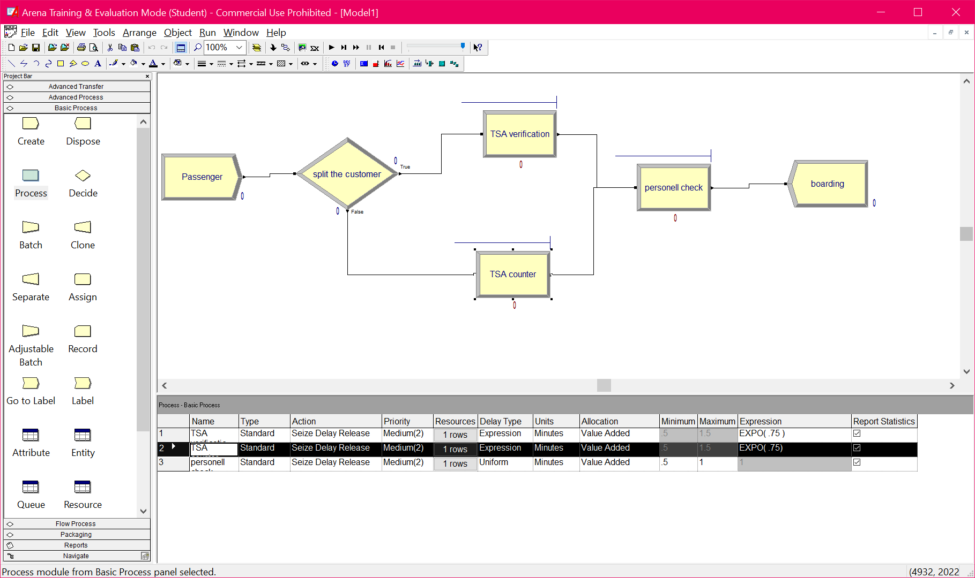

Verification:-

1. Final design achieved 9 mins of maximum average wait time.
2. Further tuning causes SIMAN error due to limitation as I have only trial version.

See attached report.

